²⁹Si and ²⁷Al MAS NMR analysis of Arumetsa clay samples

Experimental

Two powder samples have been studied:
- Arumetsa clay initial
- Arumetsa clay heated at 900 ℃

²⁹Si MAS NMR spectra were recorded on Bruker AVANCE-II spectrometer in 14.1 T magnetic field using home built MAS probe for 4 mm od Si3N4 rotors. The spectra were accumulated at 10 kHz sample spinning speed with a single 5 μs pulse (π/2) excitation at 119.23 MHz and a relaxation delay 30 s. The chemical shifts are given in TMS scale.
²⁷Al MAS-NMR spectra were recorded at 156.4 MHz on the same Bruker AVANCE-II spectrometer at 14.1 T external field using Bruker MAS probe and 3.2 mm Si3N4 rotors. The spectra were collected by single 0.5 μs pulse (π/12) excitation with repetition time 0.1 s and 20 kHz sample spinning frequency. The short excitation pulse has been used to get comparable intensities for octahedral sites having small quadrupolar coupling and tetrahedral sites having large quadrupolar coupling. (see Ref. 1). The spectra are referenced to the frequency of AlNO₃ aqua solution.

²⁷Al and ²⁹Si MAS NMR spectra

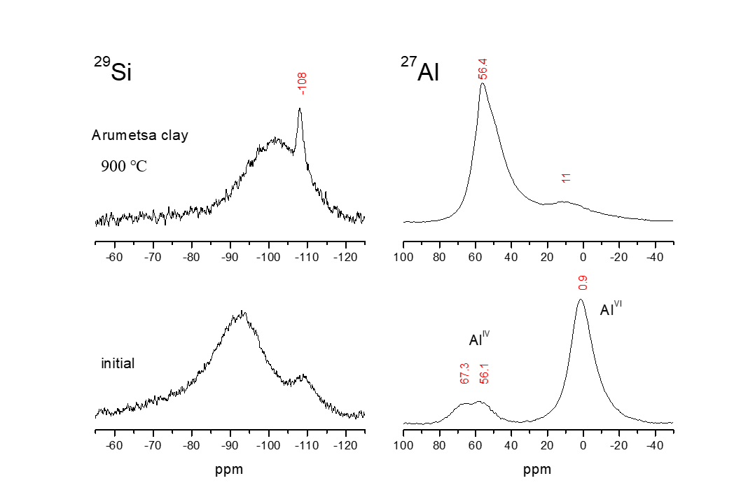

Figure 1.²⁹Si (left panels) and ²⁷Al (right panels) MAS NMR spectra of Arumetsa clay samples. The ²⁹Si spectrum of initial clay consists of a broad resonance with a maximum at -93 ppm and a shoulder at 109 ppm. After heating at 900 ℃ the resonance becomes narrower and the maximum shifts to -102 ppm. The narrow peak at -108 ppm can be assigned to almost crystalline SiO₂. The ²⁷Al spectrum of initial clay shows the main peak at 0.9 ppm belonging to octahedral aluminum sites. The two peaks at 56.1 and 67.3 ppm belong to the tetrahedral aluminum sites. After calcination, the spectrum shows that majority of the aluminum obtains tetrahedral surrounding as seen in the spectrum in right top panel.

References

- K. J. D. MacKenzie, M. E. Smith, Multinuclear Solid-State NMR of Inorganic Materials, Pergamon, 2002.
- G. Engelhardt, D. Michel, High-Resolution Solid-State NMR of Silicates and Zeolites, J. Wiley & Sons, 1987.

